|  |  |  |  |
| --- | --- | --- | --- |
| Course: | HD in Artificial Intelligence and Robotics |  | Official Use |
| Course code: | EG114728 |  |
| Module: | Industrial Automation |  |
| Module code: | MBS4521 |  |

**Lab 4:**

**Programmable Logic Controller I – Internal Relay, Timer, Counter**

|  |  |  |  |
| --- | --- | --- | --- |
| Student Name: | Cheung Tsz Chun Noddy |  | **Notes to Students**:   1. Maximum of 4 members per group for software/hardware development 2. Submit this lab sheet in pen writing 3. **Individual submission required** 4. Use spaces given for each part 5. Due date will be given in lab session 6. A maximum of 5% will be deducted for untidiness 7. Late submission will normally not be accepted |
| Student number: | 220171174 |  |
| Names of other members: | 1.  2.  3. |  |
| Date received:  Due date: | 1/4 |  |
| Signature: | Noddy |  |

**Objective**

After completion of this lab, students should be able to:

1. design sequential control pneumatic circuit ladder with a PLC software.

2. build and debug PLC pneumatic circuits and test with PLC ladder.

3. control stepping motor with PLC’s special function.

**Introduction**

With previous experience in PLC ladder design with simple I/O circuits, students should be able to control more real world systems with different type of sensors and actuators.

In this lab, pneumatic circuits will be used as a stepping stone to prepare for more sophisticated I/O devices, for example, IR/Induction/Capacitance/Magnetic sensors, stepping motors and sevomotors.

In this laboratory session, students are required to work as a group of 4 members (maximum). Each group is required to write and design PLC ladder diagram and connect I/O devices to test the functionality of programs. Every student should hand in his/her own lab sheet one week after the lab session.

**Apparatus**

1. Programmable Logic Controller software (Panasonic NAIS FP Win GR ver. 2.0)

2. PLC – FP Sigma (Model: FPG-C32T2H)

3. Personal computers

4. I/O Hub, Button-Light Box, cable and accessories

5. Electro-pneumatic components, Pneumatic training board

6. Sensors and motors.

**Procedures**

**Part A – Programmable Logic Controller Basic (70%)**

**Basic PLC circuit with Input/Output, Internal Relay, Timer and Counter:**

|  |
| --- |
| **A1.** Sketch the **input** circuitry schematic of the PLC that you are using. In your sketch, draw an **input device** to show a complete external connection. |

|  |
| --- |
| **A2.** Sketch the **output** circuitry schematic of the PLC that you are using. In your sketch, draw an **output device** to show a complete external connection. |

Throughout this lab, the external Input/Output connections required are shown below:

* Connect two momentary pushbuttons (PB1 & PB2) and one bistable pushbutton (PB3) to the input terminals X0, X1 and X2.
* Connect three 24Vdc lights, RED, YELLOW and GREEN to the output terminals Y0, Y1 and Y2.

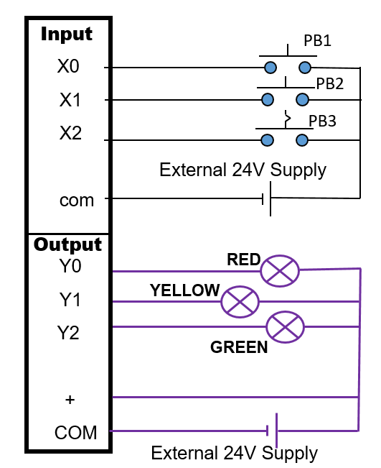

**A3 –A6: Simple ON/OFF Control**

|  |  |  |  |  |  |  |  |  |  |  |  |  |  |  |  |  |  |  |  |  |  |
| --- | --- | --- | --- | --- | --- | --- | --- | --- | --- | --- | --- | --- | --- | --- | --- | --- | --- | --- | --- | --- | --- |
| **A3.** Complete the below I/O Assignment Table:   |  |  |  | | --- | --- | --- | | **Connected to** | **Input address** | **Output address** | | Pushbutton PB1 (NO) | X0 |  | | Pushbutton PB2 (NO) | X1 |  | | Pushbutton PB3 (NO) | X2 |  | | RED light |  | Y0 | | YELLOW light |  | Y1 | | GREEN light |  | Y2 | |

|  |
| --- |
| **A4.**  Design a circuit to test all the 8 input terminals and 8 output terminals. Draw the ladder below. Write down below if any terminal is not functioning. |

Official use:

Satisfactory / Minor assistance required / Major assistance required / Incomplete

|  |
| --- |
| **A5.** Design a PLC ladder with the following requirement:   * When PB1 is pressed, only RED is turned on * When PB2 is pressed, RED and YELLOW are turned on * When PB3 is pressed, ALL lights are turned on |

Official use:

Satisfactory / Minor assistance required / Major assistance required / Incomplete

|  |
| --- |
| **A6.** The circuit below has been used in Lab 2.    Use the RED light to represent the motor, draw the equivalent PLC ladder below and test the function. You may try to connect the output to a 24Vdc motor instead. |

Official use:

Satisfactory / Minor assistance required / Major assistance required / Incomplete

**A7 – A9: Timer related circuit**

|  |
| --- |
| **A7.** **Delay ON and Delay OFF problem**  Sequence requirement:   * When PB1 (NO) is pressed and hold, the motor (you may use actual motor of a RED light to represent the motor) will be turned on after 5 seconds * When PB1 is released, the motor will keeps on running for another 10 seconds and then turns off   **Draw a timing diagram for the sequence.**    **Design a PLC ladder for the above system.** |

Official use:

Satisfactory / Minor assistance required / Major assistance required / Incomplete

|  |
| --- |
| **A8.** **Use TWO timers to create a pulse (PWM) output**  Sequence requirement:   * When PB1 (NO) is momentarily pressed, the GREEN light will start flashing on and off (turn ON for 2 seconds and turn OFF for 3 seconds repeatedly)   **Design a PLC ladder for the above system.** |

Official use:

Satisfactory / Minor assistance required / Major assistance required / Incomplete

|  |
| --- |
| **A9.** **Traffic light problem**  Sequence requirement:   * When PB1 (NO) is momentarily pressed, RED light immediately turns on * 5 seconds after RED light is on, YELLOW light turns on (RED keeps on) * 2 seconds later, RED and YELLOW turn off and GREEN light turns on * 10 seconds later, GREEN turns off and YELLOW turns on again * 1 second later, YELLOW turns off and cycle restarts   PB2 (NO) is used to reset the system.  **Draw a timing diagram for the sequence.**    **Design a PLC ladder for the above system.** |

Official use:

Satisfactory / Minor assistance required / Major assistance required / Incomplete

**A10: Counter and Timer Circuit**

|  |
| --- |
| **A10.**  **Counter-timer problem**  Sequence requirement:   * When PB1 (NO) is pressed 5 times and PB2 (NO) is pressed 8 times, RED light immediately turns on * 5 seconds after RED light is on, it will turn off automatically and system will be reset.   **Draw a timing diagram for the sequence.**    **Design a PLC ladder for the above system.** |

Official use:

Satisfactory / Minor assistance required / Major assistance required / Incomplete

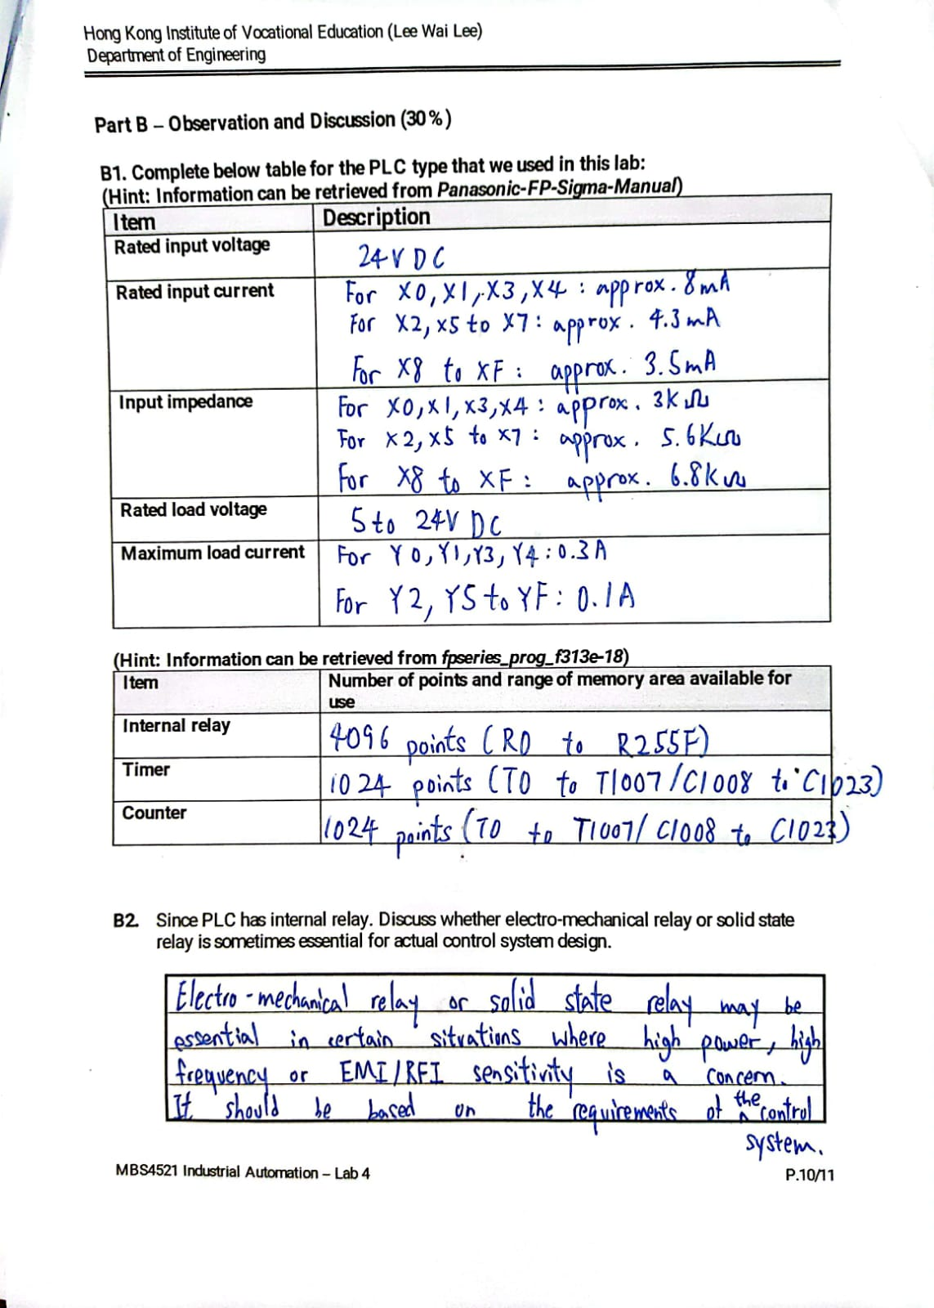

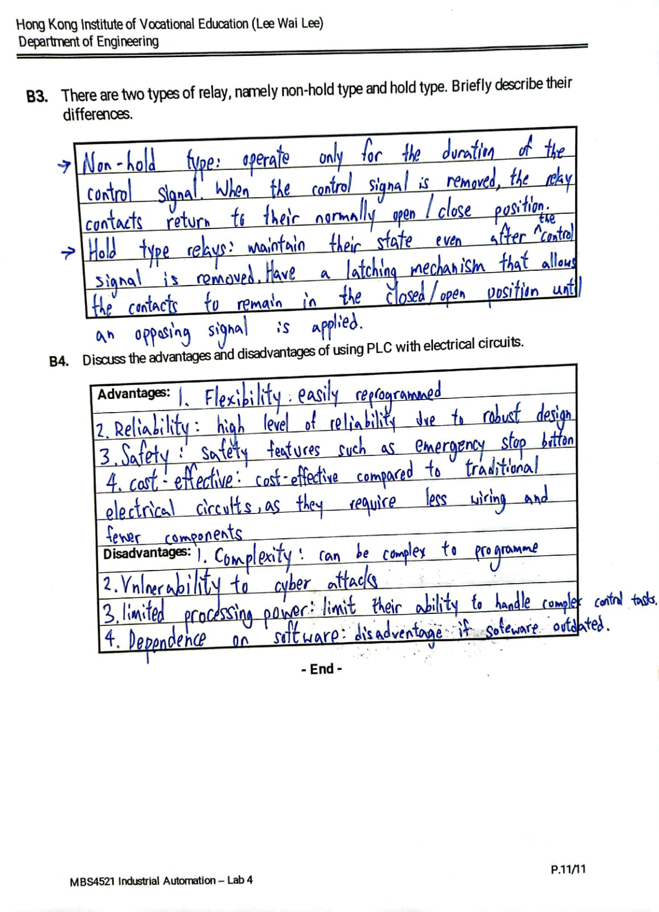

**- End -**